**Project Report Template**

**Title of Project:** Career path  
**Name of the Innovator:** Bhavya G   
**Start Date:** 27-10-2025

**End Date: 31-10-2025**

***Day 1: Empathise & Define***

*Step 1: Understanding the Need*

* Which problem am I trying to solve?

In today’s fast-paced world, people often overlook early signs of health issues until they become severe. Traditional healthcare systems focus mainly on treatment rather than prevention. There is a growing need for a **real-time, intelligent health monitoring system** that can continuously track vital signs, analyze patterns, and alert users or doctors about potential risks before they become critical.

* Who is affected by this problem?
* How did I find out about this? [Select whichever is applicable]
* Interviews
* Observation
* Online Research
* AI Tools

*Step 2: What is the problem?*

**Many people fail to detect early signs of health issues due to the lack of continuous monitoring and timely medical insights. Traditional healthcare systems mainly provide reactive care—treating diseases after they occur—instead of preventive care. As a result, conditions like diabetes, hypertension, and heart disease often go unnoticed until they become serious.**

**There is a need for a smart, AI-based system that can monitor vital signs in real time, analyze health data, and alert users or doctors about potential risks before they become critical.**

**Would you like me to simplify it into a 2–3 line version for a project report heading or poster?**

**Top of Form**

**Bottom of Form**

**Take-home task**

Ask 2-3 people what they think about the project:

**Student (Engineering background):**  
*"HealthIQ sounds like a really useful system! Using AI to track health in real time could help people detect problems early and prevent serious diseases. It’s a smart mix of technology and healthcare."*

**2. Healthcare Professional:**  
*"If implemented correctly, this could reduce hospital visits and improve patient monitoring. The challenge will be ensuring data accuracy and privacy, but the potential for better preventive care is huge."*

**3. General User:**  
*"I’d love something like this that keeps track of my health automatically. It would make me feel more in control, especially if it gives easy-to-understand alerts or advice."*

*AI Tools you can use for Step 1 and 2:*

**AI Tools Used:**

**1. Meta MGX**

* **Used as a no-code development tool to design and deploy the *healthIQ* app.**
* **It helps create interactive workflows, user interfaces, and logic without programming.**
* **Ideal for building features like user registration, location-based data, and skill modules.**

**2. ChatGPT**

* **Used for idea generation, content structuring, and chatbot conversation design.**
* **Helped in framing the AI-powered virtual assistant’s responses for guiding students.**
* **Also useful for generating recommendations, FAQs, and improving user interaction flow.**

**3. Chatbot References (Structure Design):  
To design the AI virtual assistant, you can take reference from:**

* **Google Dialogflow – for understanding intent detection and response flow.**
* **IBM Watson Assistant – for creating structured Q&A and personalized HEALTH guidance.**
* **Microsoft Bot Framework – for understanding conversation trees and user profile integration.**

***Day 2: Ideate***

*Step 3: Brainstorming solutions*

List **at least 5 different solutions** (wild or realistic):

1. ***AI-Powered Health Band (Realistic)*** *A wearable device that continuously monitors heart rate, blood pressure, oxygen level, and sleep patterns, then sends data to the HealthIQ app for analysis and alerts.*
2. ***Smart Mirror Health Scanner (Wild)*** *A mirror equipped with sensors and a camera that analyzes facial patterns, skin tone, and pupil movement every morning to detect signs of stress, fatigue, or illness.*
3. ***Virtual Health Assistant (Realistic)*** *An AI chatbot integrated into the HealthIQ app that gives personalized health tips, reminds users to take medication, and alerts them if their readings are abnormal.*
4. ***Predictive Health Dashboard (Realistic)*** *A cloud-based platform for doctors and hospitals that collects patients’ real-time data and uses AI to predict potential health risks before symptoms appear.*
5. ***Smart Clothing with Embedded Sensors (Wild)*** *Clothes with built-in biometric sensors that can monitor posture, temperature, and hydration levels while sending continuous health updates to the user’s smartphone.*

*Step 4: My favourite solution:*

*My favourite solution is the* ***AI-Powered Health Band****. It is a wearable device that continuously tracks vital signs such as heart rate, blood pressure, oxygen level, and activity patterns. The collected data is sent to the* ***HealthIQ mobile app****, where AI algorithms analyze it to provide personalized health insights and early warnings about potential health risks.*

*Step 5: Why am I choosing this solution?*

*I am choosing the* ***AI-Powered Health Band*** *because it offers a* ***realistic and effective way*** *to monitor health in real time. It is* ***portable, easy to use, and affordable****, making it suitable for people of all age groups. This solution helps in* ***early detection of health problems*** *and encourages individuals to take* ***preventive measures*** *before conditions become serious.*

**AI Tools for Step 3–5**

**1. Meta MGX**

* Used to **design and build the HEALTH IQ app** without coding.
* Helps create the **AI assistant, skill modules, and location-based features**.

**2. ChatGPT**

* Helps **brainstorm solutions** and generate ideas for driving safety guidance features.
* Can **structure conversations** for the AI virtual assistant.
* Assists in writing content for skill modules, FAQs, and recommendations.

**3. AI Chatbot References (for design and flow)**

* **Dialogflow** – Understands user intent and conversation flow.
* **IBM Watson Assistant** – Helps design structured Q&A for personalized guidance.
* **Microsoft Bot Framework** – Shows how to connect user inputs with recommendations and actions.

**4. AI Research Tools**

* **Google Scholar / Research AI** – For exploring existing solutions and innovative ideas for Steps 3–5.
* **AI Text & Summarization Tools** – Helps summarize solutions, select the best approach, and present them clearly.

*AI Tools you can use for the take-home task:*

**Canva AI/CoPilot AI/Meta AI:** Use these mobile-based tools to generate images for the solution they want to design

***Day 3: Prototype & Test***

*Step 6: Prototype – Building my first version*

What will my solution look like?

**My prototype of HealthIQ will be a smart health monitoring system that combines a wearable health band and a mobile application.**

**The wearable band will include basic sensors such as:**

* **Heart rate sensor to measure pulse rate**
* **Temperature sensor to monitor body temperature**
* **SpO₂ sensor to check oxygen levels**
* **Accelerometer to track activity and movement**

**These sensors will send data to the HealthIQ mobile app via Bluetooth. The app will display real-time readings, provide AI-based health insights, and send alerts if any vital signs go beyond normal limits.**

**The first version will focus on:**

* **Simple, accurate data collection**
* **Real-time display of key health metrics**
* **Basic AI alerts for abnormal readings**

**Design Style:**

* Modern and Minimalistic: Clean interface with simple icons, clear typography, and an intuitive layout for easy navigation.
* Dark Mode UI: Optimized for night driving to reduce glare and improve visibility.
* Real-Time Dashboard: Dynamic charts and gauges to display speed, fatigue level, and distance from obstacles.
* Responsive Design: Works smoothly on desktops, tablets, and smartphones for accessibility on the go.
* Color Scheme: Combination of dark gray, blue, and red accents to convey professionalism and alertness.
* User-Centered: Focused on clarity and safety, ensuring that alerts and data visuals are easy to read while driving.

**Prototype Tools:**

* Built using **Meta MGX**, no coding required, with all features **interactive and testable**.

What AI tools will I need to build this?

**AI Tools Needed to Build Health IQ**

1. **Meta MGX**
   * No-code platform to **design and deploy the app**.
   * Allows building **interactive screens, chat interfaces, and skill modules** without coding.
2. **ChatGPT (or similar LLMs)**
   * To **generate content, conversation flows, and driving safety responses**.
   * Can help **personalize recommendations** for users based on their profile and location.
3. **AI Chatbot Design References**
   * **Google Dialogflow / IBM Watson Assistant / Microsoft Bot Framework**
   * To **structure conversation logic** and handle user queries effectively.
4. **AI Recommendation Tools** *(Optional but useful)*
   * Could use **ML-based ranking algorithms** or **existing AI APIs** for personalization.
5. **AI Data Analysis Tools** *(Optional for insights)*
   * **Python AI libraries (Pandas, Scikit-learn)** or **AI analytics platforms**

What AI tools I finally selected to build this solution?

1. **Chat GPT**
2. **Metamgx**

**< Build The Innovation>**

**<DASHBOAD OF THE TOOL>**

**Tool Link:** https://9000-firebase-studio-1761728093167.cluster-ubrd2huk7jh6otbgyei4h62ope.cloudworkstations.dev

Internal Working of tool:

Profile Creation:

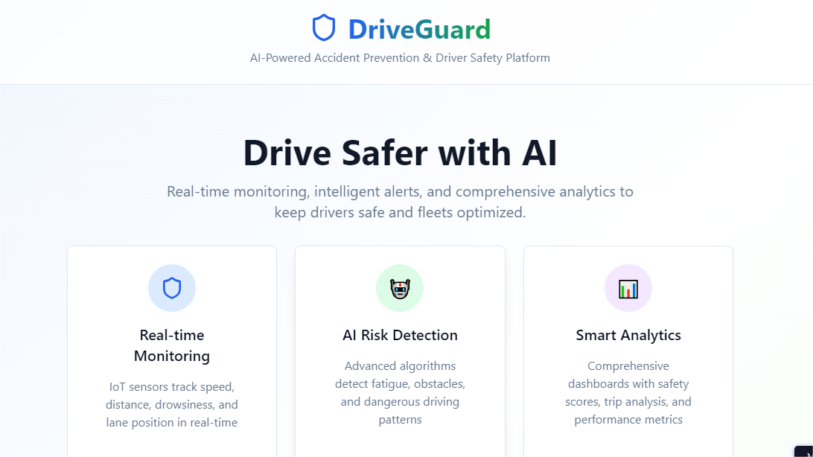

Tailoring recommendations using virtual assistant:

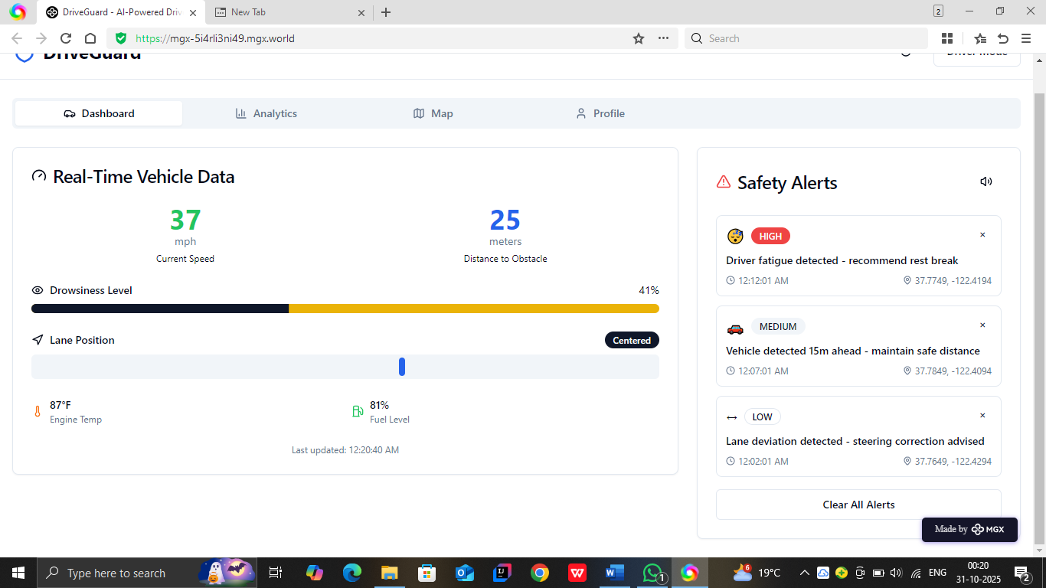

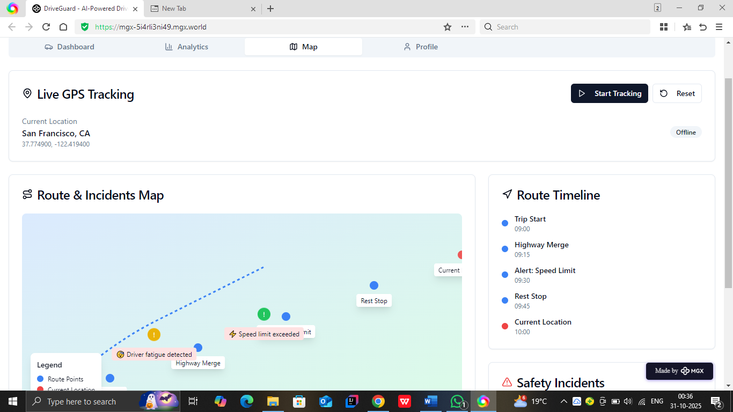

*Step 7: Test – Getting Feedback*

* Who did I share my solution with?

I shared my **CareerPath** solution with:

* **Driving Instructor** – To understand how the system can help improve driver awareness and reduce accidents.
* **Engineering Student** – To get technical feedback on using AI and IoT for real-time monitoring.
* **Fleet Manager** – To learn how the system can help track multiple vehicles and ensure safer driving in transport operations.

What feedback did I receive?

**Feedback: Pros and Cons**

**Pros (Positive Insights from Feedback):**

1. Helps **reduce accidents** by detecting driver fatigue and distractions early.
2. Provides **real-time alerts** that can save lives and improve road safety.
3. Useful for **commercial fleets** to monitor driver performance and behavior.
4. Combines **AI and IoT effectively**, making it a modern and innovative solution.
5. Can be **scaled and customized** for different types of vehicles.

**Cons (Areas to Improve Noted in Feedback):**

1. **Helps reduce accidents by detecting driver fatigue and distractions early.**
2. **Provides real-time alerts that can save lives and improve road safety.**
3. **Useful for commercial fleets to monitor driver performance and behavior.**

**My Response for The Feedback:**  
I appreciate the feedback and agree that balancing cost, accuracy, and user comfort is important. To address these points, I plan to:

1. Use **low-cost IoT sensors** and open-source AI models to make the system affordable.
2. Add **offline functionality**, so basic alerts work even without internet access.
3. Improve **sensor calibration and AI training** to ensure reliable performance in all conditions.
4. Design **customizable alert settings** so drivers can adjust sensitivity and reduce distractions.
5. Continue testing and collecting feedback to make the system more user-friendly and effective.

👍 What works well:

**What Works Well**

* **Real-Time Monitoring:** Continuously tracks driver behavior, vehicle speed, and surroundings using IoT sensors and cameras.

**AI-Powered Alerts:** Detects drowsiness, distraction, or unsafe driving patterns and provides instant visual and audio warnings.

* **Accident Prevention:** Predictive AI analytics help identify potential collisions before they occur, enhancing road safety.
* **Data Insights:** Safety reports, trip summaries, and performance analytics help drivers improve over time.
* **Fleet Management:** Admins can monitor multiple vehicles, view driver statistics, and ensure safe operations.
* **Mobile-Friendly Dashboard:** Responsive interface with dark mode for easy use during both day and night driving..

🔧 What needs improvement

1. **Cost Optimization:** The hardware setup and sensors may be expensive for personal vehicle users.
2. **Connectivity Dependence:** Continuous internet access is required for real-time tracking and data updates.
3. **Sensor Accuracy:** Environmental factors like poor lighting or weather may affect camera and sensor performance.
4. **User Adaptability:** Some drivers may take time to get used to frequent alerts and system notifications.
5. **Data Privacy:** Needs stronger encryption and user consent features to protect sensitive driving data.

*AI Tools you can use for Step 6-7:*

**ChatGPT/Perplexity AI/Claude AI/Canva AI/Chatling AI/Figma AI/Metamgx/Gamma AI**: You can use these tools to build solutions/models or mock-up dummy prototypes

***Day 4: Showcase*****🚘 Step 8: Presenting My Innovation – DriveGuard**

**Project Title: *DriveGuard – AI-Powered Accident Prevention System***

**Overview:**DriveGuard is an AI and IoT-based driver safety platform designed to reduce road accidents by monitoring driver behavior and vehicle conditions in real time. It provides instant alerts for fatigue, distraction, and collision risks, helping drivers stay aware and safe.

Key Features:

* Real-time monitoring of driver and vehicle using IoT sensors.
* AI-powered detection of fatigue, drowsiness, and unsafe driving patterns.
* Instant audio-visual alerts to prevent accidents.
* Dashboard showing safety score, trip data, and driver performance.
* Fleet monitoring system for admin and transport companies.
* Mobile-friendly interface with dark mode for night driving.

Impact:  
DriveGuard enhances road safety, saves lives, and encourages responsible driving. It is scalable for both personal vehicles and commercial fleets, contributing to a smarter and safer transportation system.

Presentation Goal:  
To demonstrate how technology—through AI and IoT—can proactively prevent accidents, promote safe driving habits, and transform road safety into a data-driven, intelligent system..

**<SHOWCASE YOUR INNOVATION TO YOUR PEERS>**

*Step 9: Reflections*

* What did I enjoy the most during this project-based learning activity?

I enjoyed the process of **combining AI and IoT technologies** to create a real-world safety solution. It was exciting to see how data from sensors could be turned into **smart, life-saving insights** using AI. I also liked **designing the dashboard interface** and exploring how technology can make driving safer and more efficient.

What was my biggest challenge during this project-based learning activity?

My biggest challenge was **integrating AI predictions with real-time IoT sensor data**. Ensuring smooth communication between hardware, software, and the web dashboard required a lot of testing and debugging. Managing **data accuracy, connectivity issues**, and **system responsiveness** was difficult but helped me learn how to build more reliable and efficient systems.

**Take-home task**

*AI Tools you can use for Step 8:*

[*https://github.com/kavyapeee2026/Driveguard*](https://github.com/kavyapeee2026/Driveguard)

**Canva AI:** You can use this to design your pitch document. Download your pitch document as a PDF file and upload on GitHub